쉘 스크립트 실습

20221807 이준호

Ex3-0.

-코드-

#!/bin/bash

echo hello world

exit 0

-실행 스크린샷-

Ex3-1.

-코드-

#!/bin/sh

for i in $(seq 1 $1)

do

echo hello world

done

exit 0

-실행 스크린샷-

Ex3-2.

-코드-

#!/bin/sh

echo `expr $1 $2 $3`

exit 0

-실행 스크린샷-

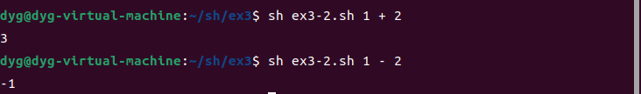

Ex3-3.

-코드-

#!/bin/sh

w=`expr $1 \* 10000`

bmi=`expr $w / \( $2 \* $2 \)`

min=18.5

min_f=${min%.*}

if [ $bmi -gt 23 ]; then

echo "overweight"

elif [ $bmi -gt $min_f ]; then

echo "normalweight"

else

echo "underweight"

fi

exit 0

-실행 스크린샷-

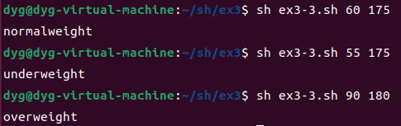

Ex3-4.

-코드-

#!/bin/sh

echo "do you enjoy Linux? (Yes/No)"

read answer

case $answer in

yes | Yes | y | Y | YES)

echo "well played";;

[n/N]*)

echo "its too bad";;

*)

echo "you must type yes or no"

exit 1;;

esac

exit 0

-실행 스크린샷-

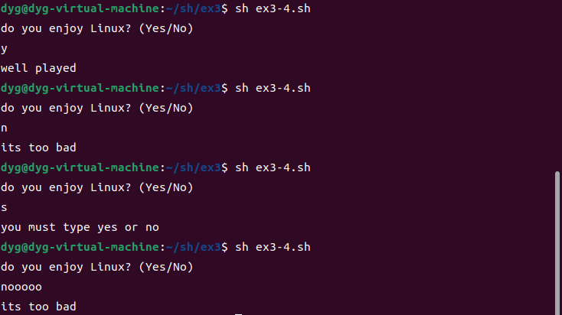

Ex3-5.

-코드-

#!/bin/sh

f(){

echo "enter the fuction"

echo $($1)

}

echo "start the program"

f $1

echo "exit the program"

exit 0

-실행 스크린샷-

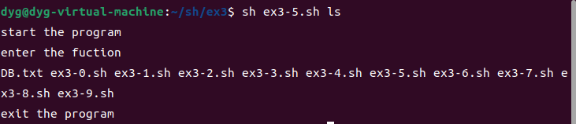

Ex3-6.

-코드-

#!/bin/sh

f=/home/dyg/sh/ex3

che=1

l=$(echo $(ls) | tr " " "\n")

for i in l

do

if [ $1 = $i ]; then

che=0

break

fi

done

if [ $che = 1 ]; then

$(mkdir $1)

fi

echo "type file name"

read fname

s=$(echo $fname | tr " " "\n")

for i in $s

do

$(touch $i)

$(mv $i $1)

done

eval "cd $1"

eval "tar -cvf $1.tar $fname"

eval "mkdir $1"

eval "mv $1.tar $1"

eval "cd $1"

eval "tar -xvf $1.tar"

-실행 스크린샷-

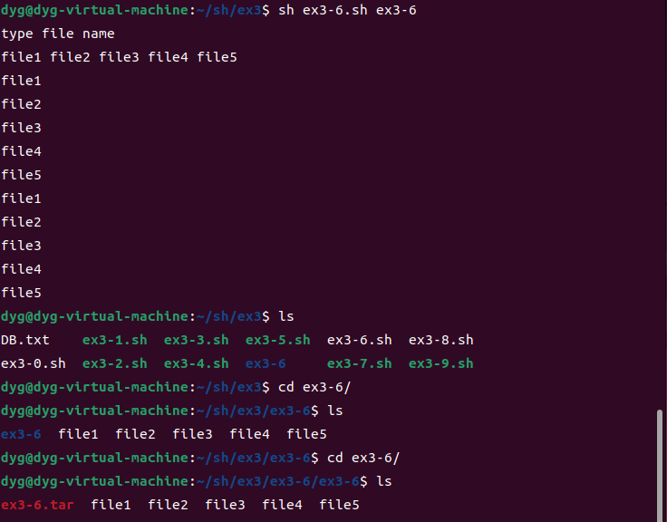

Ex3-7.

-코드-

#!/bin/sh

eval mkdir $1

eval cd $1

for i in $(seq 0 4)

do

name=file$i

eval touch $name.txt

eval mkdir $name

eval ln -sf $name.txt $name

done

exit 0

-실행 스크린샷-

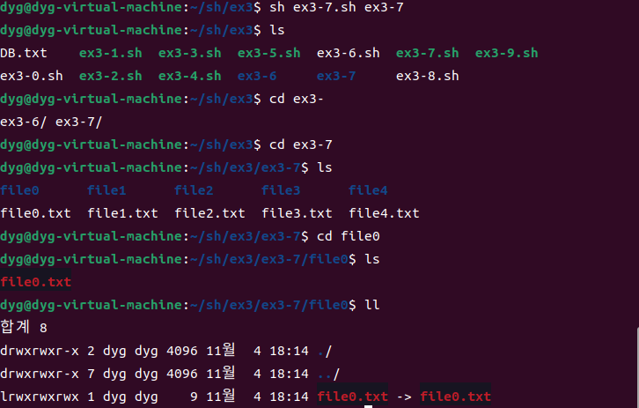

Ex3-8.

-코드-

#!/bin/sh

eval "echo "$*" >> DB.txt"

exit 0

-실행 스크린샷-

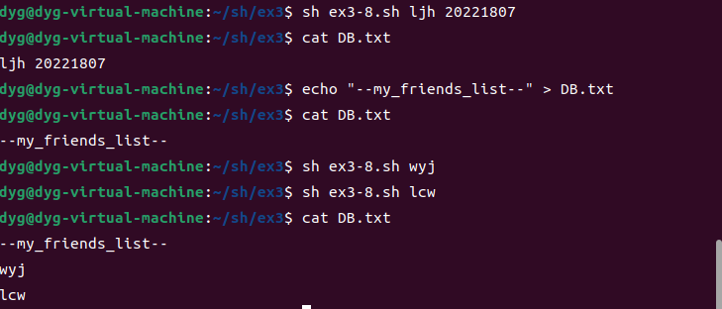

Ex3-9.

-코드-

#!/bin/sh

eval grep $1 DB.txt

-실행 스크린샷-

